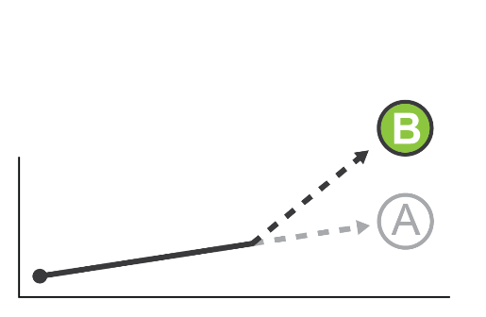
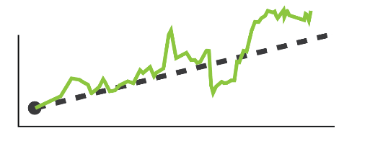
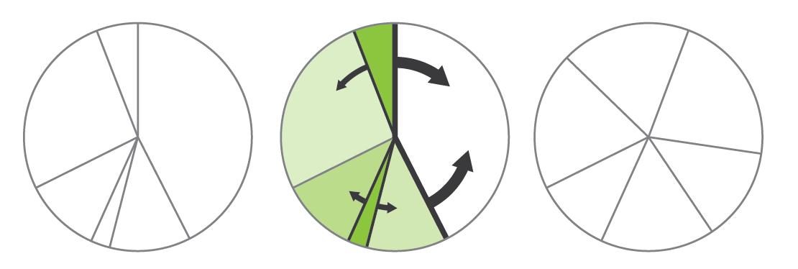

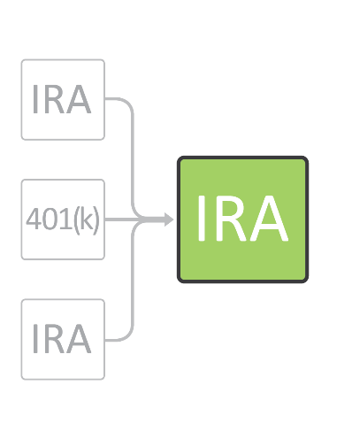
5-Point Portfolio Checkup
This checklist is only meant to identify potential problems among your investment accounts and is not a substitute for personalized professional advice.
Contact RK Wealth Management, LLC with any questions about rebalancing your portfolio or reaching your investment goals.
Update Goals
The first thing to do is determine where you want your investments to be headed. Do you have a new goal, like a child’s college fund, or have you decided to aim for a higher retirement income?
Check your Performance
Are your investments on track to meet your goals? Do you need to aim for increased investment returns or start contributing more? If your portfolio is lagging behind the appropriate benchmarks, it may be time to reconsider your investments.
Review Assets
Over time, some assets may grow to be an oversized or undersized part of your portfolio, or perhaps your appetite for risk has changed. Either way, consider rebalancing your assets and dropping individual stocks that are no longer productive.
Check your Beneficiaries
Do all of your investment accounts have listed beneficiaries? In the event of your death, having direct beneficiaries for your accounts will keep them from passing through your estate and incurring unnecessary costs.
Consolidate Extra Accounts
Many people forget about old accounts (past IRAs, CDs and 401(k)s) and do not coordinate their holdings with the rest of their portfolio. Talk to your advisor about rolling these accounts into a single IRA that will be easier to manage.

The goal of investing is to see your money grow over time. However, even though you can’t control how your investments rise and fall, your portfolio is anything but automatic. Like most things, it’s important to check up on your portfolio to make sure nothing is out of date and that its goals are still in line with your own.

